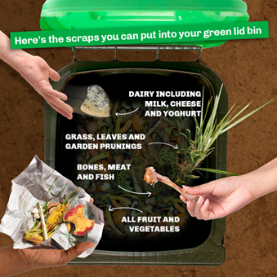
Changes to the Food and Garden Organics (lime-green lid) kerbside bin service
What changes have been made?
Food Organics and Garden Organics (FOGO) bins should now ONLY be used for food scraps and garden waste.
Fibre-based products including paper towels, cardboard or paper packaging, tissues or pizza boxes are no longer accepted in the FOGO bin. The exception to this rule is paper used to wrap food scraps (for example a kitchen caddy lined with newspaper), and Australian Certified Council approved compostable kitchen caddy liners used to contain food scraps.
Why has it changed?
Councils and our commercial compost facilities need to comply with state government legislation and policy - the NSW EPA’s Compost Order and the NSW Position Statement on FOGO. Recent testing has also found that many fibre-based products claim to be compostable but contain chemicals and substances that can harm the environment and our health. Keeping those potentially harmful items out of our green bins means that we can create high-quality commercial compost to support food production and soil health.
What can and can’t go in the FOGO bin:
What CAN go in your green FOGO bin | What should NOT go in your green FOGO bin
Fruit and vegetable scraps | Fibre-based products (bamboo, cardboard, paper etc)
Meat and bones | Paper towels, serviettes, tissues, napkins and shredded paper
Seafood and shells | Compostable or biodegradable products (excluding AS 4736-2006 kitchen caddy liners )
Pasta, bread, rice and cereal | Vacuum cleaner dust
Eggs and Dairy products | Washing machine and dryer lint
Loose tea leaves and coffee grinds | Pet poo and poo bags
Garden waste (leaves, clippings, weeds etc) | Tea and coffee bags
Council approved compostable kitchen caddy liners that comply with AS 4736-2006 and paper used to wrap food scraps. | Treated wood and timber
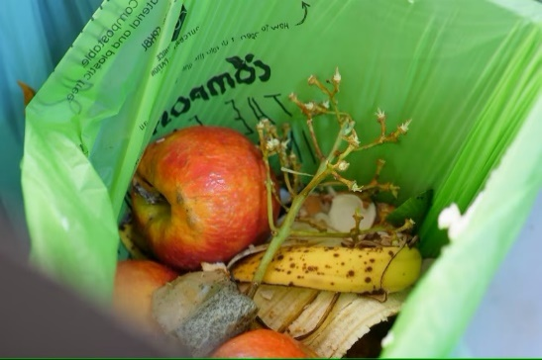
Can I still use compostable liners for my kitchen caddy and to wrap food scraps?
Yes. Council approved compostable liners – AS 4736 – 2006 and paper ( for example newspaper) can be used to wrap your kitchen scraps.

